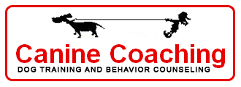
845-634-4344
info@caninecoaching.com
www.caninecoaching.com

Mental Stimulation- Busy Work
Puppies have growing minds as well as growing bodies. But inquiring minds often look for projects and the most obvious choice is sometimes chewing the sofa cushions. Providing your puppy with fun things to do on his own can help prevent behavior problems associated with boredom like barking and chewing the furniture. Along with providing a productive outlet for puppy’s problem-solving skills, toys that stimulate puppy’s mind can teach him how to settle down and be alone. Dr. Roger Abrante's suggests using 1/3 of your puppy's diet for treats to be earned during training, 1/3 to be given as usual in a food bowl, and 1/3 to be "hunted". Try a Treat Ball, an ingenious new training aid which the puppy must persistently work with to receive a few kibble at a time. Other stuffing toys, such as Kongs and sterilized bones provide similar mental stimulation. This "home alone" 1/3-1/3-1/3 program helps your puppy expend some energy and provides much needed stimulation.
The following mental exercise games and problem solving activities will help keep your puppy occupied with parent-approved projects.
- Stuffed Kongs, bully sticks, marrow bones(if your vet approves), and USA rawhides (if your vet approves)are great for puppies who need to chew
- The Tricky Treat Ball works the brain while dispensing puppy’s meal
- Plush puzzle toys (ex. Hide-A-Squirrel) are great for puppies who insist on taking the stuffing out of, well, everything
- Wrap treats in old stuffed animals and/or socks to encourage dissection. Throw items in the washer to clean and use again
- All puppies enjoy a good scavenger hunt. Once puppy has gone potty, scatter her kibble around part of the yard and encourage her to “find it.”

Plush puzzle toys  Hide-A-Squirrel  Hide-A-Bee  Intellibone  Dr. Noy’s replaceable squeaker toys | 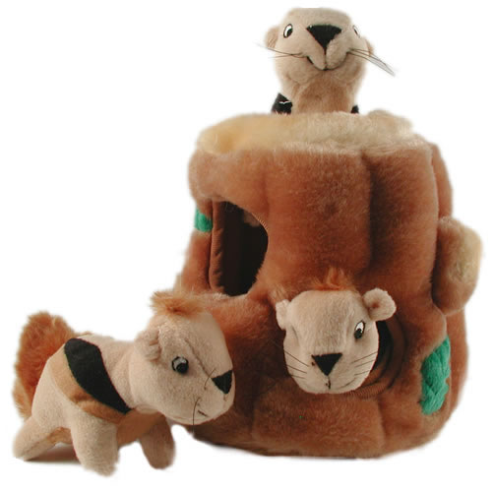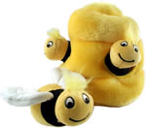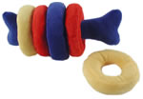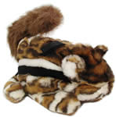
Fill with kibble & work to eat!  Tricky Treat Ball, Molecule Ball by Our Pets, Twist n Treat by Premier | 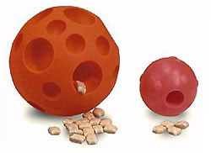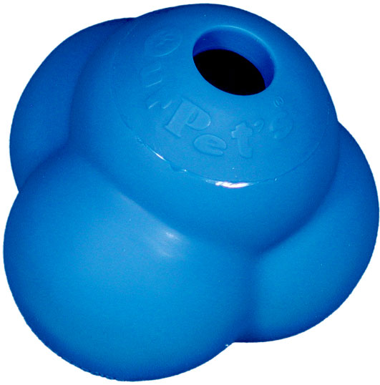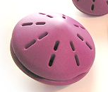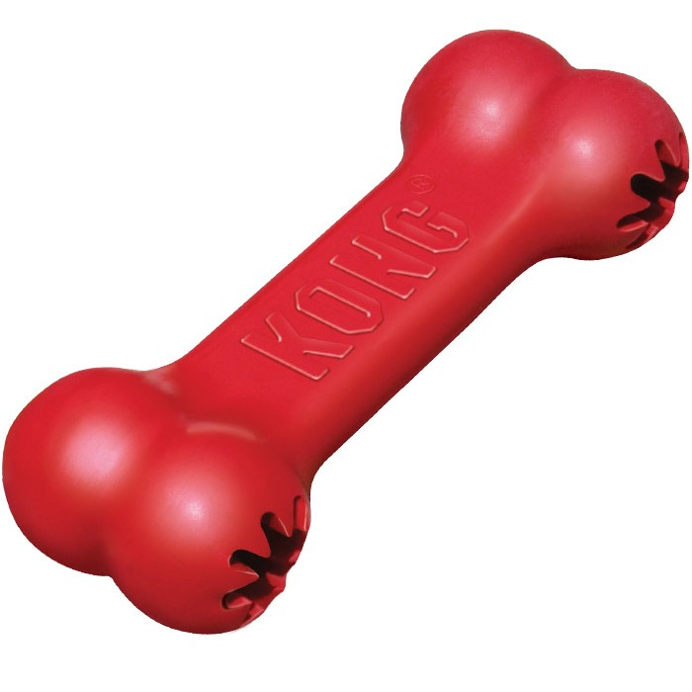
Stuff ‘em  Freeze ‘em  Hide ‘em around the house  Kong, Groove Thing by Premier  Bully sticks, flossies | 